**Test Scenarios:**

1.When the user lands on page i.e localhost:3000/ ,he will able to see details of all cities.The details are render as cards which contains information like City Names, Country additionally flag is added .

The frontend is able to retrieve the data from the backend and display it.

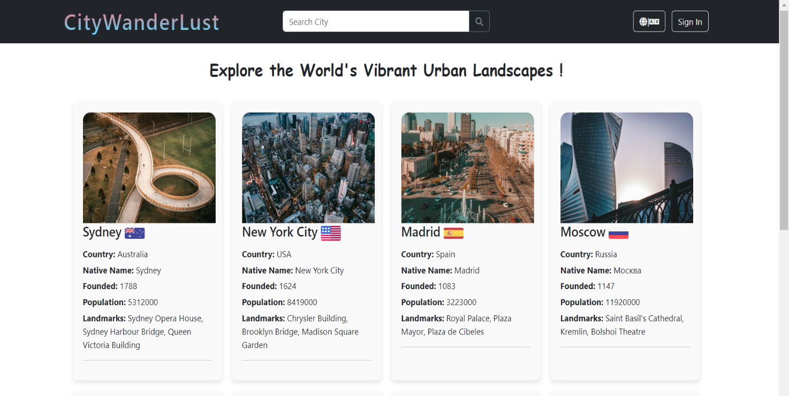

2.In the search Bar when user enters city name, all information about searched city is displayed. Below read more link is present which will redirect you to Wikipedia.

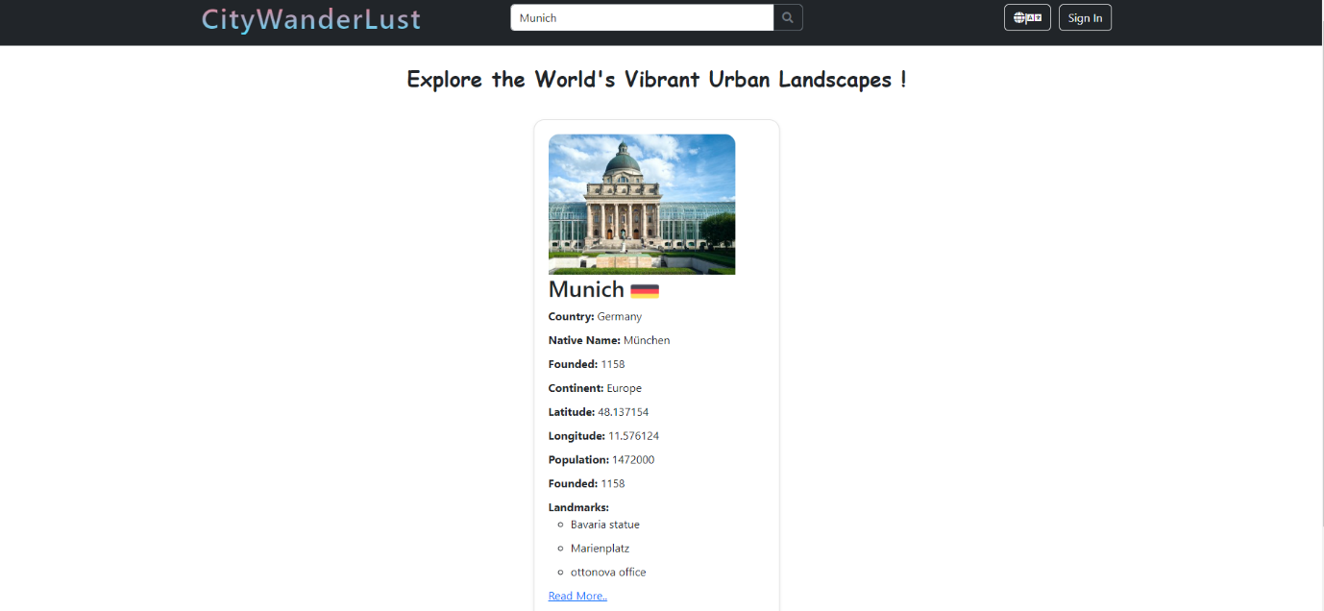

3. When user click on sign in button login form will get displayed. User need to add correct email address and password for successful login.

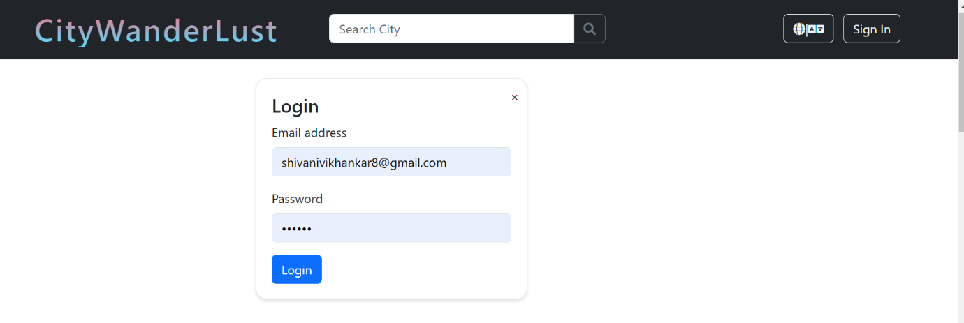

4.When user enters invalid email address error message will get displayed.

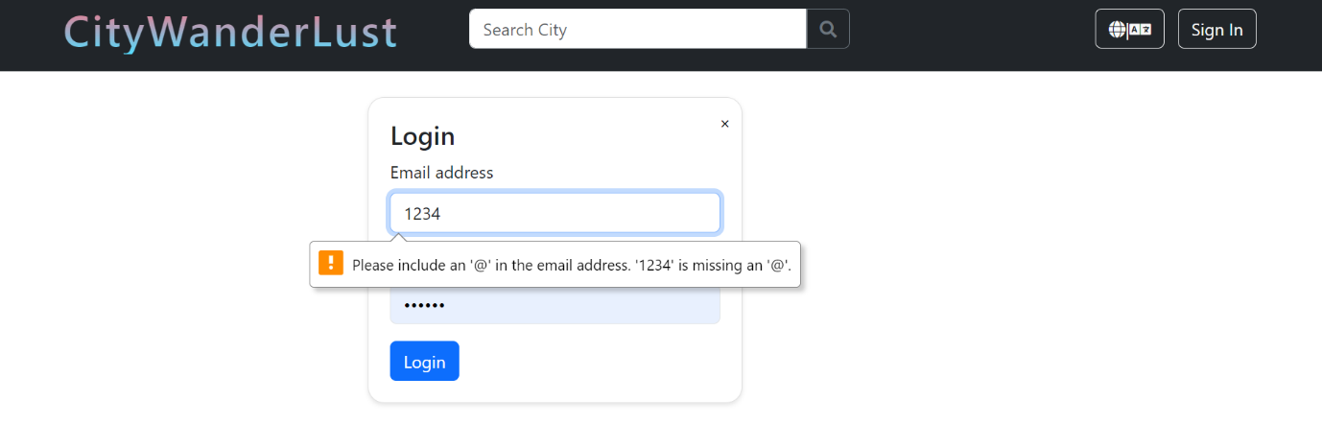

5.When user enters city which is not present in the response. Error message will get displayed.

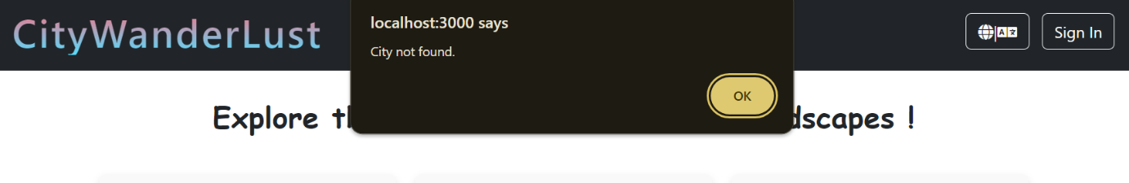

6. The backend is be able to return JSON data via a REST API endpoint.

i.e localhost:3000/cities

